**1. Instruction for model developers**

This section is specifically for the developers of the SWAT-MODFLOW model, who want to advance further the processes we incorporated into the model.

In the SWAT model source code, more than 70 modules and subroutines are directly involved in PFAS fate and transport simulation. We start with the new and essential subroutines we added or modified in the source code.

***readchm*:** This subroutine in the new model is modified to read the following variables from each HRU: 1) initial PFAS amount in soil layers, 2) the Freundlich coefficients (kf and n) corresponding to each PFAS associated with the physiochemical properties of the soil layers. This module can read the above-mentioned variables for several PFAS compounds from each soil layer of an HRU. Note: the amount of PFAS in the soil layers must be specified as μg/ha, then the module converts it to kg/ha for internal processes.

***readpfas***: This module is added to the model to read global variables in the PFAS input database (pfas.dat). These global variables are 1) percolation coefficients, 2) the PFAS molecular weights (kg/mol), and 3) the solubility (mg/l) of PFAS compounds, *KL* (l/nmol) and *Ґmax* (nmol/m2).

***pfaslch***: this module is added to the model source code to simulate PFAS fate and transport in the soil layers as described in Section 2.1 in the manuscript. It solves Equation (1) to find the PFAS equilibrium concentration at the aqueous form of the soil layer. Then, using the PFAS percolation coefficient and the amount of surface runoff, lateral flow, and percolation, the module estimates PFAS transport via surface runoff and leaching to the lower layers or moving by lateral flow to the outlet of the sub-watersheds. To solve the non-linear advection-dispersion Equation (1) as presented in the manuscript, we implemented the improved version of Halley’s method (IHM) (Barrada et al., 2020). Assuming Equation (1) is *f (x)=0* with available first and second derivatives as *f ́* (x) and *f ́ ́*(x),the IHM finds the root *(xn)* by iterating Equation (S1). To ensure convergence to the root, we implemented a bisect technique before IHM execution to find a close approximation to the root.

(S1)

***pfasy***: once the equilibrium concentration of PFAS for sorbed form is estimated from the pfaslch module, the ***pfasy*** module is called to calculate PFAS transport via sediment. Based on the enrichment ratio specified in the input files (*.chm) as well as the amount of sediment estimated by the model, the ***pfasy*** module estimates the amount of PFAS sorbed to sediment particles that end up in rivers. Note that the enrichment ratio is only for calibration purposes and should be 1 if no calibration is going to perform.

***writed***: once the PFAS transport via surface runoff and sediment is defined, this subroutine writes them in the “output.pfas.”

**readmgt**: This subroutine reads variables for PFAS input to the soil via biosolid application. These variables include the time of application (either with head units or date), the management operation corresponding to PFAS biosolid application which in this case is number 18, the soil depth that PFAS will be added via biosolid, and the amount of PFAS (mg/ha) added to the soil via biosolid.

***applypfas***: This module adds PFAS via biosolid to the soil. The application (time and amount) that we specify in the input management files (*.mgt) and read by the **readmgt** module will be scheduled by the ***sched_mgt*** module, and then the ***applypfas*** module is called to apply PFAS to the soil andwrite the application time and amount into “output.mgt.” Based on the depth of biosolid application, the ***applypfas*** module adds PFAS to the soil layer. Note: the amount of PFAS must be specified as mg/ha in the input management files, then the module converts it into kg/ha in the model.

***readswq***: This subroutine, like readchm, is modified to read the PFAS fate and transport parameters for each sub-watershed river. These parameters include PFAS partition coefficients between water and solid (*kd*), settling velocity, resuspension velocity, initial PFAS concentration in riverbed sediments, PFAS burial velocity in riverbed sediment, and the depth of active sediment layer for PFAS accumulation.

***rtpfas***: this module solves the PFAS balance in rivers by taking into consideration other processes such as settling, resuspension, diffusion, and burial processes. Once a river receives the PFAS from soil layers or subbasins, it will be partitioned into soluble and sorbed forms, and then the above-mentioned processes take place to either exchange PFAS between the water and sediment layer or transport them to the downstream river.

**rchday**: Once the PFAS water balance calculation is finished, **rchday** subroutine is calledto write PFAS in river output (“output.rch”). Variables of this output can be controlled in the output control file (file.ico). The reach output variables corresponding to soluble PFAS river input is #47, soluble PFAS river output is #48, sorbed PFAS river input is #49, sorbed PFAS river output is #50, PFAS in riverbed sediment is #51, PFAS removed by burial processes is #52, diffused PFAS exchange between water and sediment is #53, PFAS resuspended from the riverbed is #54 PFAS settled in riverbed sediment is #55. Note: all the variables in the output have the mg unit.

***readlwq***: This subroutine is precisely like ***readswq*** subroutine but with the following differences: 1) it reads PFAS fate and transport parameters for lakes instead of rivers, and it also reads the initial PFAS concentration in the lakes.

***Lakeqpfas***: this module, like rtpfas, solves the PFAS balance in lakes. The PFAS that is routed from rivers to the lakes or wetlands (or any water bodies specified via .res input files and added to the hydrograph storage file (“fig.fig”) will go through similar processes mentioned in the ***rtpfas*** module***.*** The output of this module feeds the subsequent hydrograph storage (usually the downstream river).

**routres**: Once the PFAS fate and transport in lakes is defined, this module is called to route the PFAS output to the next hydrograph storage and then write the PFAS mass balance components in the “output.rsv.”

**pfasw**: At the end of the simulation period, this subroutine writes the overall PFAS balance in the watershed, including 1) the amount of PFAS applied by biosolid, 2) The initial and final amount of PFAS in soil, 3) PFAS contributed to streams by surface runoff, lateral flow, leaching to GW and transported by sediment and soil erosion.

**1.1. An overview of source code local and global variables.**

There are more than 150 global and local variables that are added to the model source code to specifically work for PFAS fate and transport simulations in soil, rivers, and lakes, including initialization, mass balance calculation, routing, reading inputs, and writing outputs in the form of daily, monthly, and annually. The definition and application of many of these parameters are described in the source code of the above-mentioned subroutines. However, a collection of essential variables are provided in Table 1. Note: there are several unit conversions within the source code that model developers need to consider carefully. Units for the initial PFAS amount defined in *.chm files are µg/ha. The amount of PFAS in biosolid defined in *.mgt files is mg/ha. Once they are read, both these values are converted to kg/ha for PFAS fate and transport in soil. For writing the output, routing PFAS in the river network, and PFAS balance in river and lake processes, everything is based on mg or mg/l.

**Table 1:** Collection of new and modified global variables in the SWAT source code.

|  |  |
| --- | --- |
| **Variable** | **Definition** |
| chpfas_koc | PFAS partition coefficient between water and sediment in reach |
| chpfas_mix | Mixing velocity (diffusion/dispersion) for PFAS in reach |
| chpfas_rsp | Resuspension velocity in reach for PFAS sorbed to sediment |
| chpfas_stl | Settling velocity in reach for PFAS sorbed to sediment |
| hrupfasd (hru,1,type) | Amount of PFAS type in surface runoff |
| hrupfasd (hru,2,type) | Amount of PFAS type in surface runoff |
| hrupfasd (hru,3,type) | Total PFAS loading to stream in surface via sediment and surface runoff |
| hrupfasd (hru,4, type) | Amount of PFAS type in lateral flow |
| hrupfasd (hru,5, type) | Amount of PFAS type in leaching to GW |
| hrupfasm (hru,1-4, type) | Amount of PFAS type in surface runoff, sediment, total and lateral flow (monthly) |
| hrupfasa (hru,1-4, type) | Amount of PFAS type in surface runoff, sediment, total and lateral flow (average annual) |
| hrupfasy (hru,1-4, type) | Amount of PFAS type in surface runoff, sediment, total and lateral flow (annual) |
| ipfasp | Print code for output.pfas file |
| irtpfas | The PFAS number to be routed through the river network |
| lkpfas_conc | PFAS concentration in lake water |
| lkpfas_koc | PFAS partition coefficient between water and sediment in lake water |
| lkpfas_mass | Amount of PFAS in lake water |
| lkpfas_mix | Mixing velocity (diffusion/dispersion) in lake water for PFAS |
| lkpfas_rsp | Resuspension velocity in lake water for PFAS sorbed to sediment |
| lkpfas_stl | Settling velocity in lake water for PFAS sorbed to sediment |
| lkspfas_act | Depth of active sediment layer in lake for PFAS |
| lkspfas_bry | PFAS burial velocity in lakebed sediment |
| lkspfas_conc | PFAS concentration in lakebed sediment |
| mpfas | Max number of PFAS used in watershed |
| mpfasdp | Max number of PFAS in PFAS.dat |
| pdvar(47) | Soluble pfas into the river (mg) |
| pdvar(48) | Soluble pfas out of the river (mg) |
| pdvar(49) | sorbed PFAS transported into reach |
| pdvar(50) | sorbed PFAS transported out of reach |
| pdvar(51) | Amount of PFAS stored in river bed- writing variable |
| pdvar(52) | Amount of PFAS in sediment layer lost through burial - writing variable |
| pdvar(53) | Amount of PFAS diffusing from reach to bed sediment- writing variable |
| pdvar(54) | Amount of PFAS resuspended from bed sediment to reach- writing variable |
| pdvar(55) | Amount of PFAS settling out of reach to bed sediment during simulation- writing variable |
| PFASbry | Loss of PFAS from active sediment layer by burial |
| pfasdb | Name of PFAS database input file(pfas.dat) |
| PFASdfs | diffusion of PFAS from sediment to lake |
| pfasin | total PFAS transported into reach |
| pfasname | name of PFAS |
| rchaao(45,river) | soluble PFAS transported into reach during simulation- writing variable |
| rchaao(46,river) | soluble PFAS transported out of reach during simulation- writing variable |
| rchaao(47,river) | sorbed PFAS transported into reach during simulation- writing variable |
| rchaao(48,river) | sorbed PFAS transported out of reach during simulation- writing variable |
| rchaao(49,river) | amount of PFAS in sediment layer lost through burial during simulation- writing variable |
| rchaao(50,river) | amount of PFAS diffusing from reach to bed sediment during simulation- writing variable |
| rchaao(51,river) | amount of PFAS resuspended from bed sediment to reach during simulation- writing variable |
| rchaao(52,river) | amount of PFAS settling out of reach to bed sediment during simulation- writing variable |
| rchdy(61) | soluble PFAS transported into reach on day |
| rchdy(62) | soluble PFAS transported out of reach on day |
| rchdy(63) | sorbed PFAS transported into reach on day |
| rchdy(64) | sorbed PFAS transported out of reach on day |
| rchdy(65) | amount of PFAS stored in river bed sediments |
| rchdy(66) | amount of PFAS in sediment layer lost through burial on day |
| rchdy(67) | amount of PFAS diffusing from reach to bed sediment on day |
| rchdy(68) | amount of PFAS resuspended from bed sediment to reach on day |
| rchdy(69) | amount of PFAS settling out of reach to bed sediment on day |
| rchmono (60,river) | soluble PFAS transported into reach during month |
| rchmono (61,river) | soluble PFAS transported out of reach during month |
| rchmono (62,river) | sorbed PFAS transported into reach during month |
| rchmono (63,river) | sorbed PFAS transported out of reach during month |
| rchmono(64,river) | Amount of PFAS in sediment layer lost through burial during month |
| rchmono(65,river) | Amount of PFAS diffusing from reach to bed sediment during month |
| rchmono(66,river) | Amount of pfas resuspended from bed sediment to reach during month |
| rchmono(67,river) | Amount of PFAS settling out of reach to bed sediment during month |
| rchyro(42, river) | Soluble PFAS transported into reach during year |
| rchyro(43, river) | Soluble PFAS transported out of reach during year |
| rchyro(44, river) | Sorbed PFAS transported into reach during year |
| rchyro(45, river) | Sorbed PFAS transported out of reach during year |
| rchyro(46, river) | Amount of PFAS in sediment layer lost through burial during year |
| rchyro(47, river) | Amount of PFAS diffusing from reach to bed sediment during year |
| rchyro(48, river) | Amount of PFAS resuspended from bed sediment to reach during year |
| rchyro(49, river) | Amount of PFAS settling out of reach to bed sediment during year |
| resoutm(42, river) | PFAS entering reservoir during month |
| resoutm(43, river) | PFAS moving from water to sediment through settling during month |
| resoutm(44, river) | PFAS moving from sediment to water through resuspension during month |
| resoutm(45, river) | PFAS moving from water to sediment through diffusion during month |
| resoutm(46, river) | PFAS lost from reservoir sediment layer through burial during month |
| resoutm(47, river) | PFAS transported out of reservoir during month |
| resoutm(48, river) | PFAS concentration in reservoir water during month |
| resoutm(49, river) | PFAS concentration in reservoir sediment layer during month |
| respfasi | PFAS entering reservoir on day |
| resuspfas | amount of PFAS moving from sediment to lake water due to resuspension |
| sedpfas | PFAS in riverbed sediment |
| sedpfas_act | depth of active sediment layer in reach for PFAS accumulation |
| sedpfas_conc | initial PFAS concentration in riverbed sediment |
| sedpfasmass | PFAS amount in riverbed sediment |
| setlpfas | amount of PFAS moving from water to sediment due to settling |
| pfas_mw | PFAS molecular weight |
| pfas_kl | Concentration independent Langmuir coefficient |
| pfas_N | the Freundlich exponent n |
| pfas_kf | Freundlich PFAS sorption coefficient |
| pfas_sol | PFAS maximum solubility |
| sol_pfas | amount of PFAS in layer |
| pfas_Cw | the aqueous-phase equilibrium concentration of PFAS |
| pfassol | amount of PFAS type leached from soil |profile on current day |
| PFAS_AW | Active Surface Area of Porous media |
|  |  |

**2. Preparing model input files for PFAS fate and transport simulation:**

For the new SWAT-MODFLOW model input files, the user should create a pfas database (pfas.dat) files and modify HRU chemical input files (*.chm), HRU soil layer file (*.sol), rivers water quality files (*.sqw), lakes water quality files (*.lwq), and configuration files (file.ico and basin.bsn).

The pfas.dat database contains those PFAS characteristics independent of the soil’s physiochemical properties. Figure 1 shows the structure of the pfas.dat file. The input file has seven columns: 1) ID is the PFAS identification number in the model, starting from one; 2) Name of the PFAS compound; 3) The percolation coefficient (the recommended range is between 0.05 to 0.2); 4) Molecular weight of the PFAS compound; 5) the solubility of the PFAS compound. The PFAS compound’s solubility is high in pure water, but it differs from natural water. Therefore, use a solubility that fits the condition in the watershed of interest; 6) the *KL* (l/nmol) or the concentration-independent Langmuir coefficient; and 7) *Ґmax* (nmol/m2) or the maximum surface concentration of the PFAS compound.

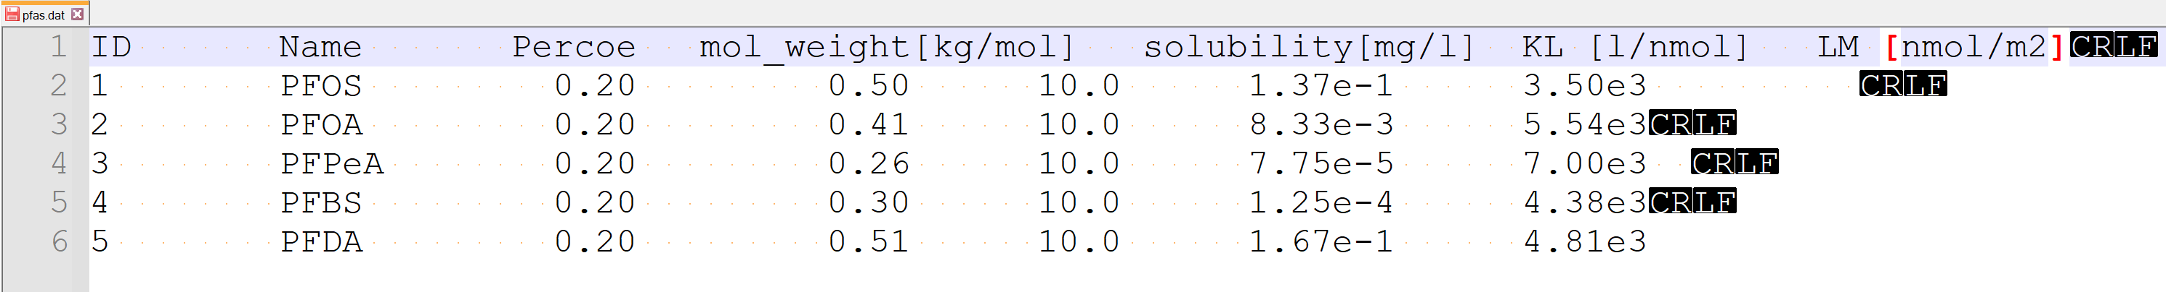

**Figure 1:** Preparing pfas.dat model input file.

The information regarding PFAS in soil, including the PFAS mass, and adsorption coefficients (*kf* and *n*), must be defined in *.chm input files. The user must provide four lines of information for each PFAS in the *.chm files as shown in Figure 2. The first column in each row is the ID of the PFAS, corresponding to the PFAS ID defined in the pfas.dat file. The rest of the columns correspond to PFAS mass, kf, and n in soil layers, starting from the first layer to the bottom of the vadose zone. The enrichment ratio must only be defined for the first layer. The range of enrichment ratio is between 0 to 1. The enrichment ratio value should be modified in the calibration processes of the model if needed; otherwise, leave it 1.

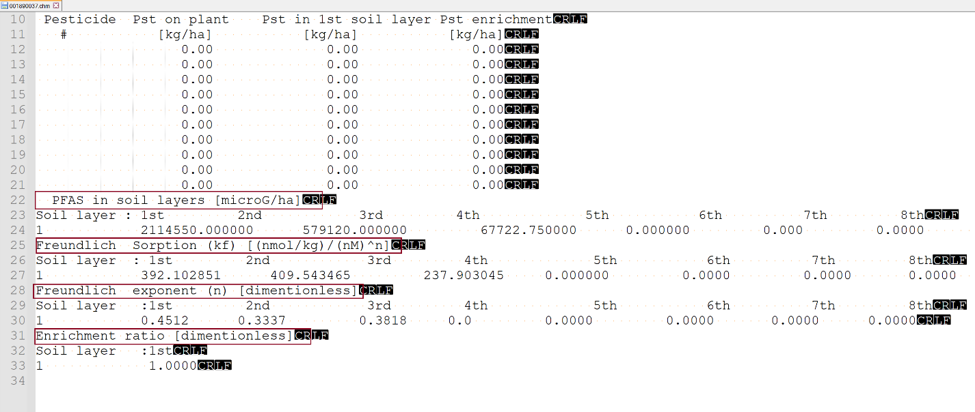

**Figure 2:** Modifying HRU chemical input files (*.chm).

The user needs to add the soil D50 for every layer of each HRU in *.sol model input files as shown in Figure 3.

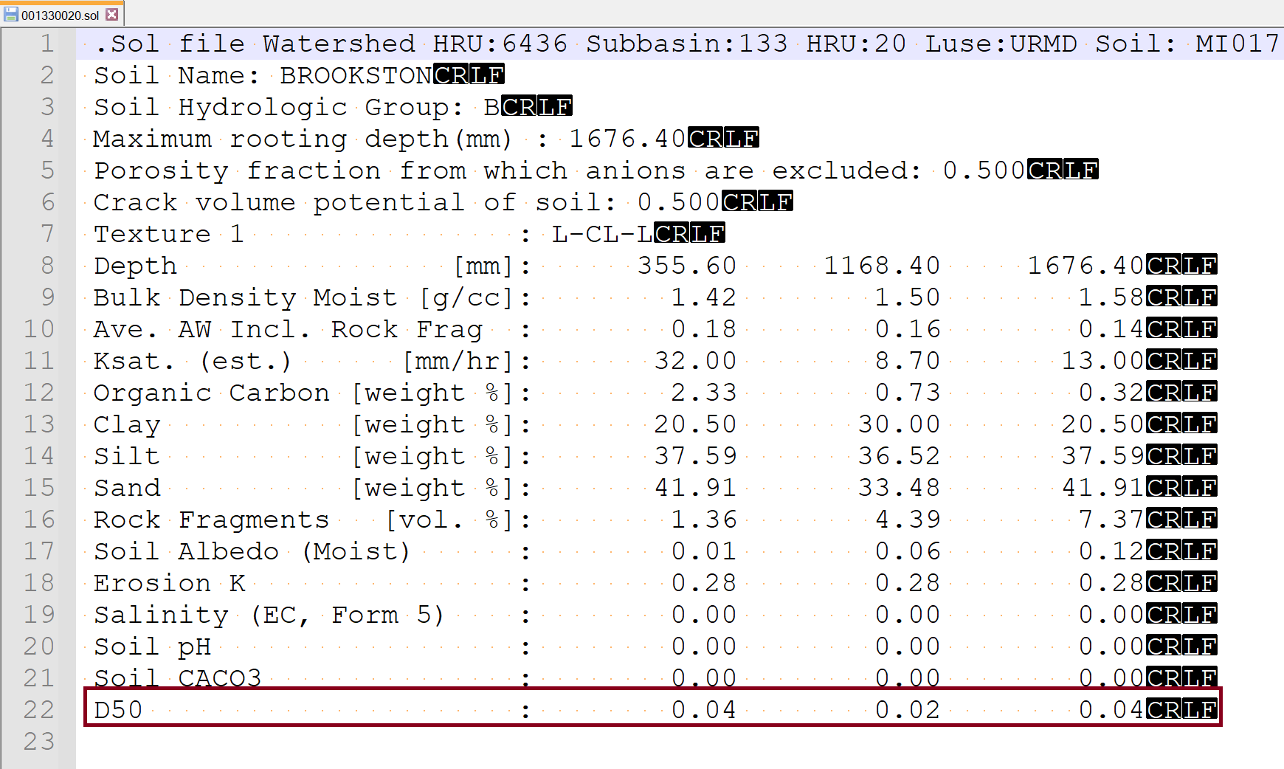

**Figure 3:** Modifying *.sol model input file for including soil D50.

The parameters related to PFAS fate and transport in impounding water bodies (lakes, reservoirs and wetlands) must be defined in *.lwq model input files, as shown in Figure S12. The description of these parameters can be seen in Figure 4.

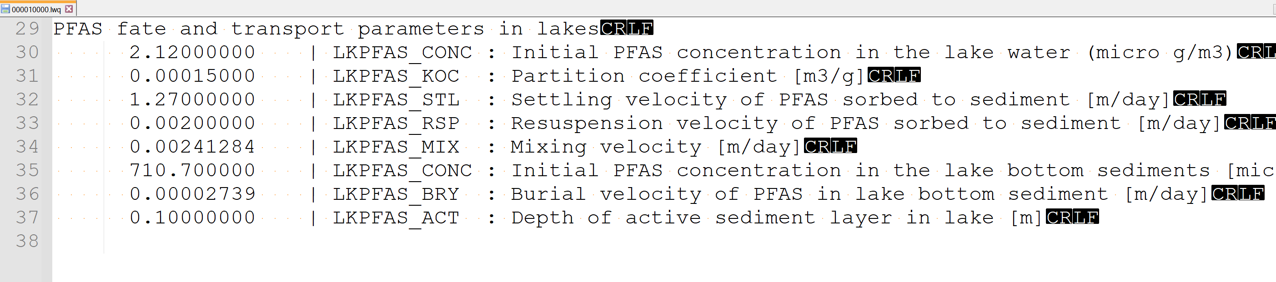

**Figure 4:** Modifying *.lwq model input files for including PFAS fate and transport parameters in lake simulation.

Similar to PFAS fate and transport parameters in impounding waterbodies, the user must define parameters related to PFAS fate and transport in rivers water quality input files (*.swq) as shown in Figure 5:

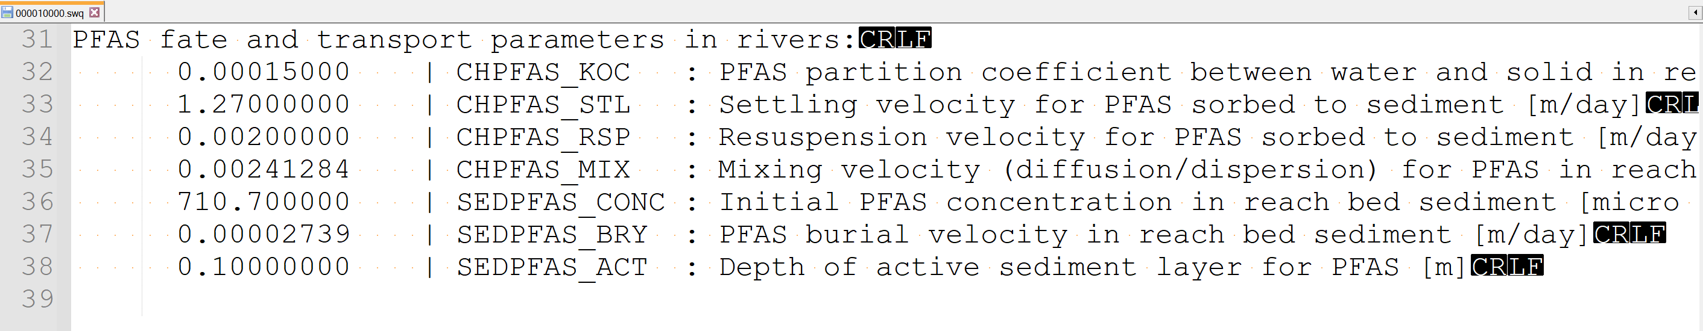

**Figure 5:** Modifying model input files for including instream PFAS fate and transport parameters.

The model can simulate an unlimited number of PFAS in the soil but can route one PFAS to the river network during the simulation period. Therefore, the ID of the PFAS that should be routed to the main channel (defined in pfas.dat) should be specified in the basin.bsn model input file as shown in Figure 6. In this example, we need to route PFOS with the ID of 1; therefore, we set IRTPFAS equal to 1 here.

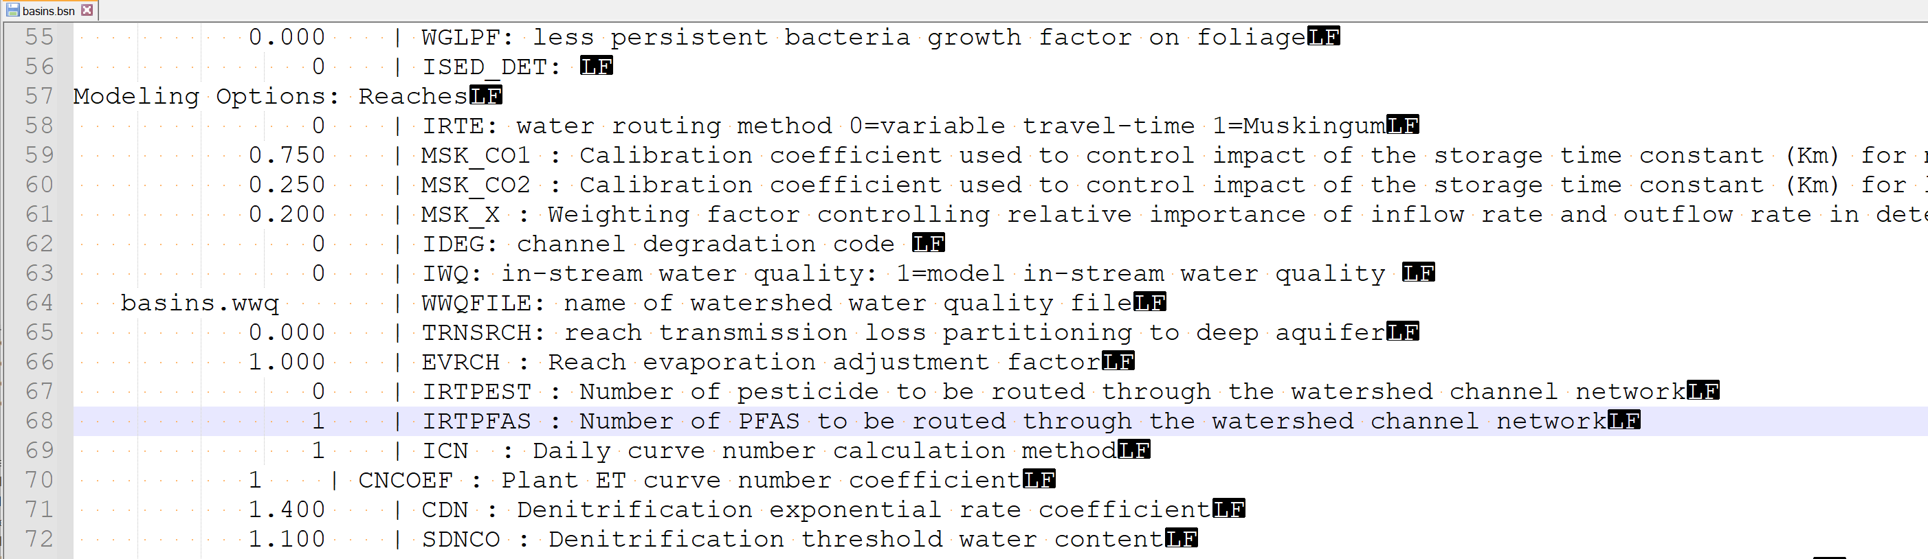

**Figure 6:** Modifying basin.bsn model input files for specifying the PFAS that need to be routed to streams

The inputs regarding WWTPs should be defined in *.pnt files. The first column is the number of days, starting from 1 and ending to 365 (or 366 in leap years). The second column is the year of simulation. The third column is the flow discharge of the WWTP (m3). The last two columns, the first one is the dissolved PFAS and the second one is the sorbed PFAS loads from the WWTP.

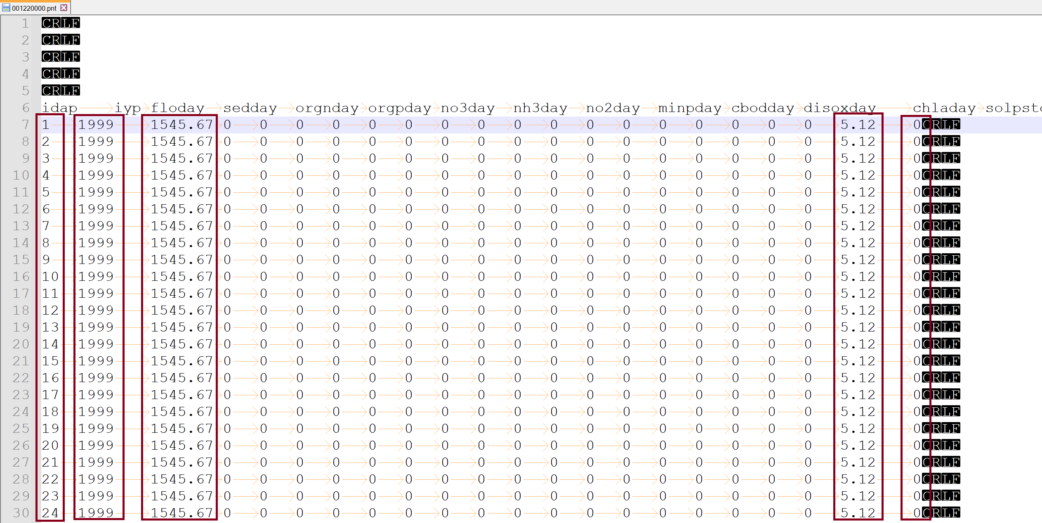

**Figure 7:** Modifying .pnt model input files for specifying PFAS loads from WWTPs to rivers

Regarding the biosolid application, the PFAS added with biosolid must be specified in *.mgt files as shown in Figure 8. The first column indicating the date of biosolid application defined with heat unit measure. The second column is the management number. The management number for biosolid application must be always 18. The third column is the PFAS ID, the fourth column is the amount of PFAS (mg/ha) added to the soil. The last column is the depth for biosolid application.

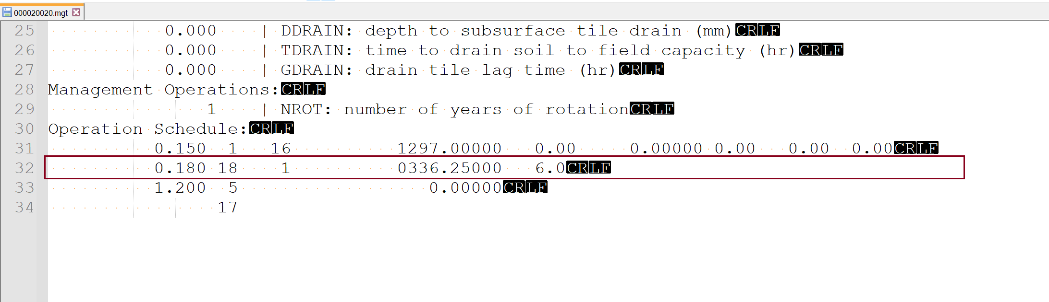

**Figure 8:** Modifying *.mgt model input files for including PFAS with biosolid application

The file.ico should be modified by the user to include the PFAS database (pfas.dat) for the model input file and command the model to print output.pfas as shown in Figure 9. Note that, when the output.pfas is on, the model print PFAS with runoff, sediment transport and leaching for every HRU. Therefore, it increases the execution time of the model.

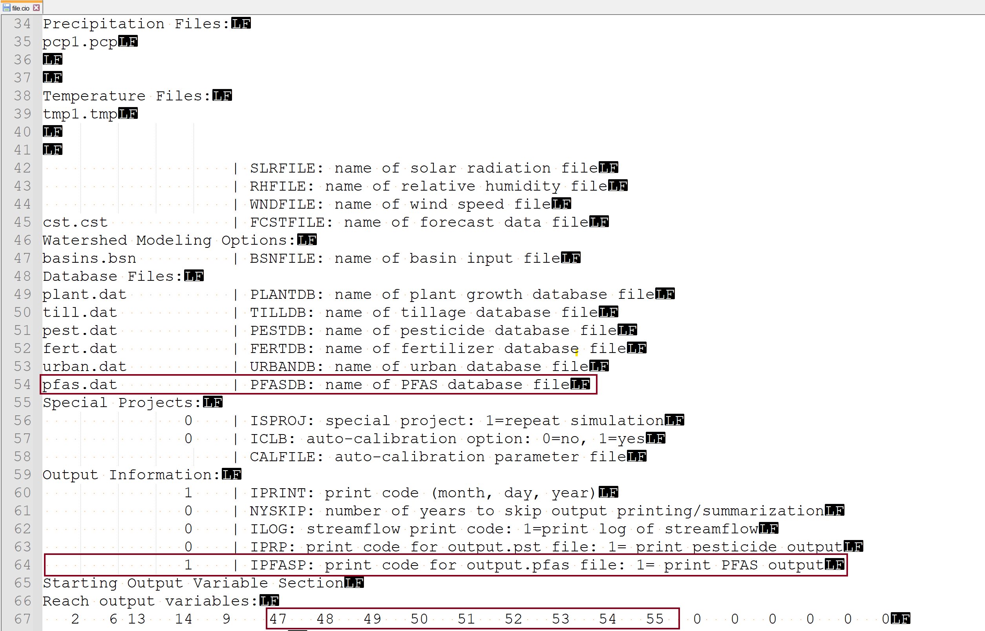

**Figure 9:** Modifying file.ico configuration file of the model.

The standard output of the model for PFAS with surface runoff, sediment transport and leaching from HRUs are shown in Figure 10:

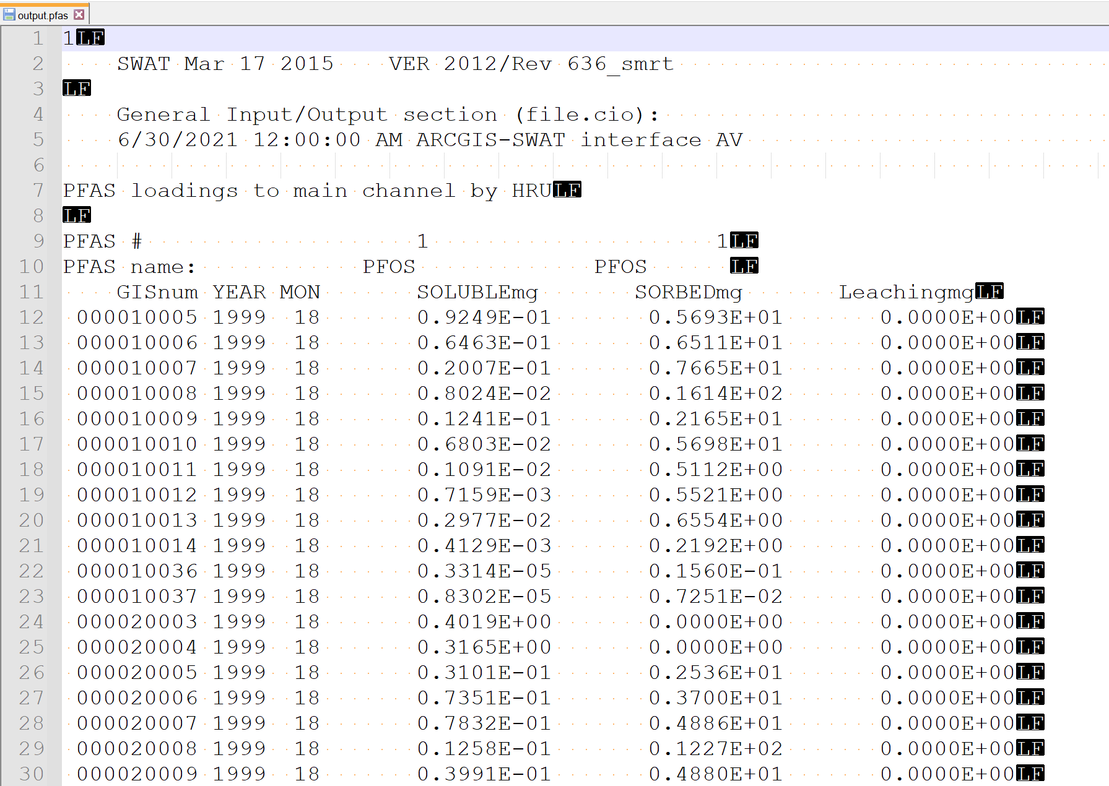

**Figure 10:** The output.pfas of the SWAT-MODFLOW model

The output.rch prints the information regarding PFAS in the rivers. The structure of the output is shown in Figure 11.

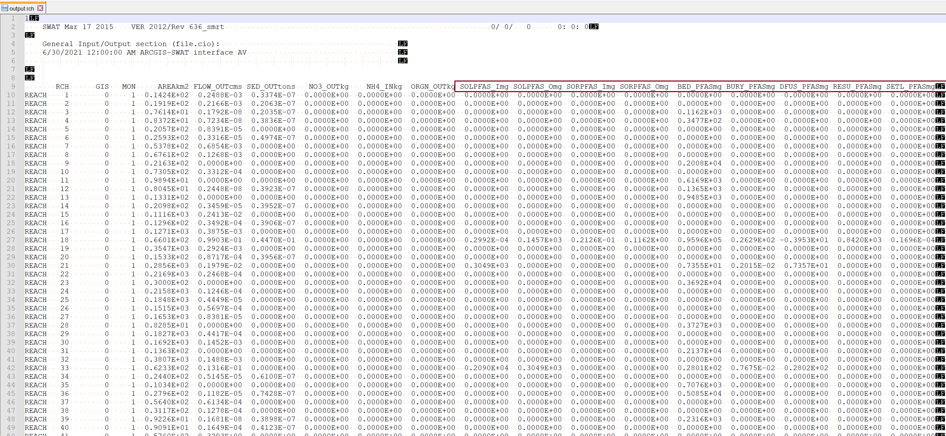

**Figure 11:** The structure of the output.rch of the SWAT-MODFLOW model

The output.rsv prints the information regarding PFAS in lakes/reservoir/wetlands (Figure 12). The output.rsv includes PFAS input and output to the water bodies as sorbed or dissolved forms, resuspension, settling, burial, and diffusion.

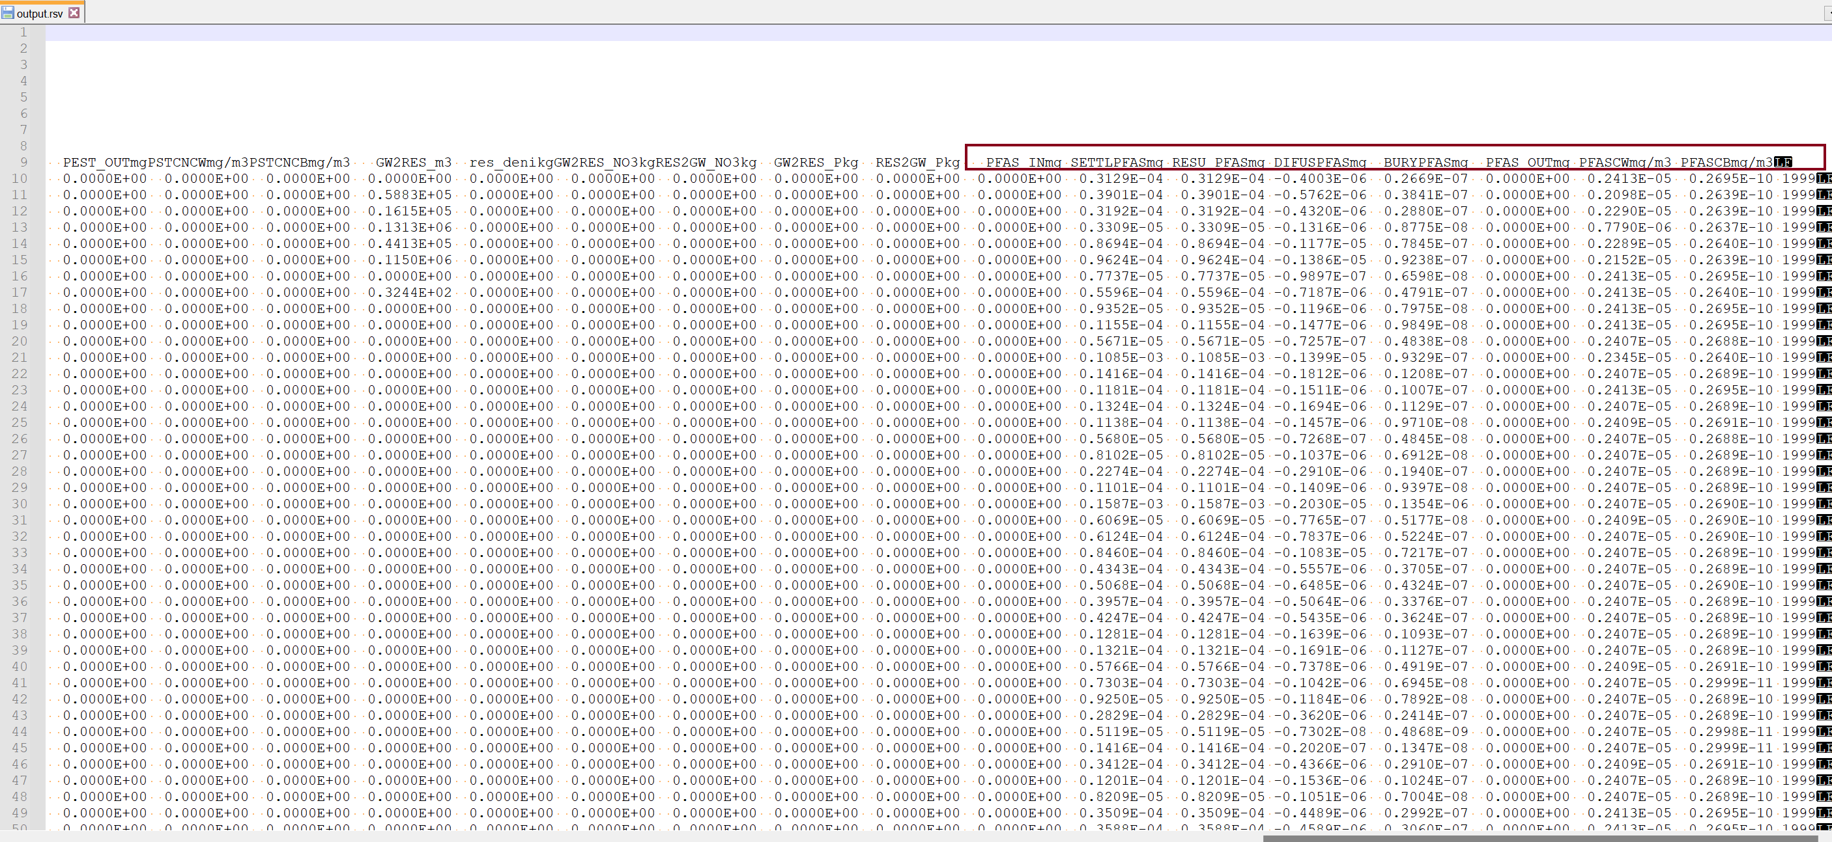

**References:**

Barrada, M., Hasnaoui, M.L., Ouaissa, M., 2020. On the Global Convergence of Improved Halley’s Method. Engineering Letters 28.